# Error message upon login to AD account after running TEMPO 2.0

# Introduction

After running the TEMPO 2.0 Installation package, and rebooting as prompted, the user receives an error message upon attempting to log in with their AD credentials. This error message can vary depending on the specific configuration of the device prior to TEMPO 2.0

These issues are caused by a change in the “unique identifier” for the affected user. A dialog box that discusses these issues is displayed during the TEMPO installation process.

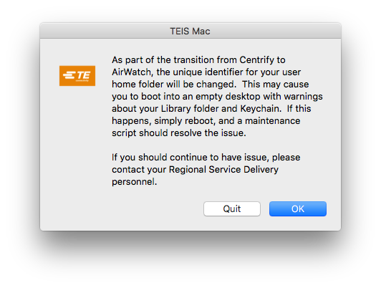

# 

# Unable to create mobile user.

## Commonly Applies to: OS X 10.10 “Yosemite” and ealier

* Boot into the local admin user
* Use Terminal to move their current home folder
  + sudo mv /Users/te012345 /Users/te012345.old
  + *Substitute their network id for “te012345” in the above command, and in the commands to follow below.*
* Log out of local admin and attempt to log in as their AD user
  + A fresh home folder will be created, and they will log into a generic desktop and dock.
* Log out of their AD user and back to the local admin
* Use Terminal to move the newly created home folder
  + sudo mv /Users/te012345 /Users/te012345.new
* Use Terminal to move their old home folder back
  + sudo mv /Users/te012345.old /Users/te012345
* Use Terminal to repair permissions on the repaired home folder
  + sudo chown –R te012345:620847553 /Users/te012345
  + The group ID 620847553 corresponds to the group “domain users” and should apply to all TE domain accounts.
* Log back in to their AD account and verify their desktop is back and usable.
* Delete /Users/te012345.new as it is no longer needed.

# OS X needs to repair your Library to run applications. Typy your password to allow this.

## Commonly Applies to: OS X 10.11 “El Capitan”

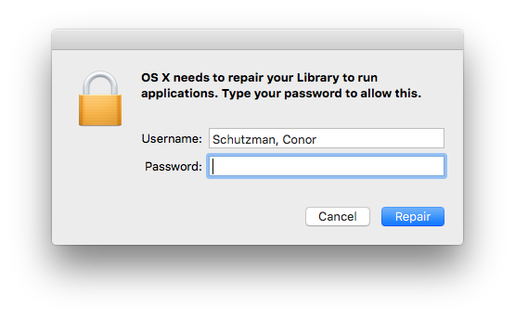

* Assuming that TEMPO 2.0 installation completed successfully, reboot. Permissions will be repaired automatically during the next boot process.
* If this repair does not happen automatically, the steps in the previous section (unable to create mobile user) can be utilized to manually repair the permissions on the user’s home folder.

If you need additional Help you can [Submit a Ticket Here](http://arsystem.tycoelectronics.com/Auth/cwf2.0.asp?catid=000000000025195) or you can call the Service Desk [Click Here](https://teams.connect.te.com/sites/SelfHelp/Information%20Documents/HelpDeskInfo.pdf)